Food UI App -Redesign
bdominiq
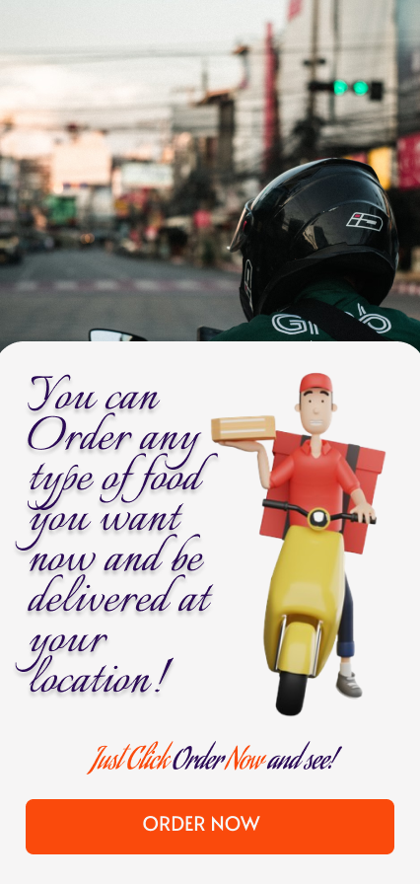
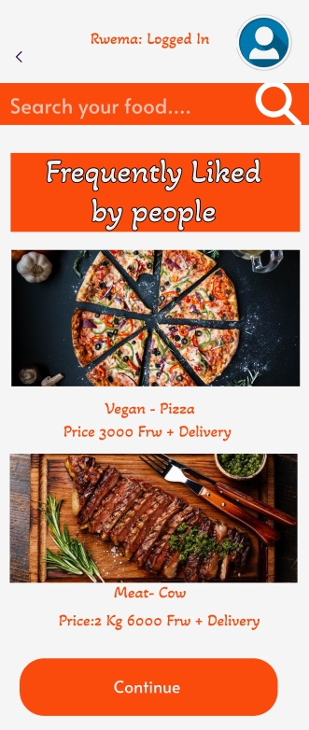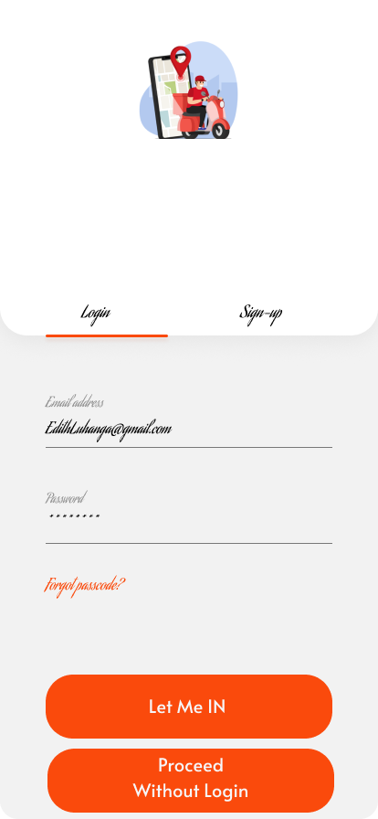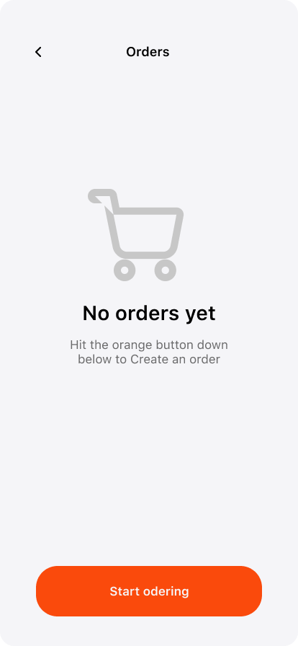
For the Constant, I've made lots of little changes to make the app easier and nicer to use. First, I added a cool logo to make the app look better and easier to recognize. Then for Repetition, I made it simpler for new users to get used to the app by adding some helpful features. I also made sure that important things like "order now" are easy to find and use by putting them in noticeable places. And by Alignment, I made sure everything looks neat and tidy by lining up stuff like sign-up forms and pictures properly. So now, the app, it's much easier to figure out what to do and where to go because everything is in the right place and easy to see which fulfills proximity principle.
---
Figma: https://www.figma.com/file/nYM0J9s7vcKcpZq8VRixRi/Mobile-app?type=design&node-id=60001-346&mode=design&t=YcC4xAQcMQe4DtVa-0

